EXP. NO: 18
MATLAB SIMULATION AND EVALUATION OF EYE DIAGRAM PARAMETERS UNDER INTER-SYMBOL INTERFERENCE IN DIGITAL COMMUNICATION SYSTEMS
Objectives
1. To simulate a digital communication system in MATLAB and generate the eye diagram
of the received signal for evaluating eye height, eye width, eye-crossing level and timing
margin.
PROGRAMMING CODE:
clc;
clear;
close all;

% EXP. NO: 18
% MATLAB Simulation and Evaluation of Eye Diagram Parameters
% Under Inter-Symbol Interference (ISI)

% 1. SYSTEM PARAMETERS
N = 1000; % Number of transmitted bits
Rb = 1000; % Bit rate in bits/second
sps = 100; % Samples per symbol
fs = Rb*sps; % Sampling frequency
Ts = 1/Rb; % Bit duration
SNR = 25; % Signal-to-noise ratio in dB

% 2. GENERATE RANDOM BINARY DATA
bits = randi([0 1], 1, N);

% Convert bits to bipolar NRZ signal
symbols = 2*bits - 1;

% 3. UPSAMPLING
tx = zeros(1, N*sps);
tx(1:sps:end) = symbols;

% 4. GENERATE CHANNEL WITH INTER-SYMBOL INTERFERENCE
% Simple channel impulse response
h = [0.2 0.6 1 0.6 0.2];

% Normalize channel
h = h/sum(h);

% Introduce ISI through channel convolution
rx_isi = conv(tx, h, 'same');

% 5. ADD AWGN NOISE
signal_power = mean(rx_isi.^2);
noise_power = signal_power/10^(SNR/10);
noise = sqrt(noise_power)*randn(size(rx_isi));

rx = rx_isi + noise;

% 6. PLOT TRANSMITTED AND RECEIVED SIGNALS
t = (0:length(tx)-1)/fs;

figure;

subplot(2,1,1);
plot(t(1:1000), tx(1:1000), 'LineWidth', 1.2);
title('Transmitted NRZ Signal');
xlabel('Time (seconds)');
ylabel('Amplitude');
grid on;

subplot(2,1,2);
plot(t(1:1000), rx(1:1000), 'LineWidth', 1.2);
title('Received Signal with ISI and AWGN');
xlabel('Time (seconds)');
ylabel('Amplitude');
grid on;

% 7. GENERATE EYE DIAGRAM
% Plot 2-bit intervals with 1-bit overlap
eye_length = 2*sps;
num_traces = min(100, floor(length(rx)/sps)-1);

figure;
hold on;

for k = 1:num_traces
start_index = (k-1)*sps + 1;
end_index = start_index + eye_length - 1;

if end_index <= length(rx)
segment = rx(start_index:end_index);
time_eye = (0:eye_length-1)/sps;

plot(time_eye, segment, 'b');
end
end

title('Eye Diagram of Received Signal Under ISI');
xlabel('Time (Bit Periods)');
ylabel('Amplitude');
xlim([0 2]);
grid on;
hold off;

% 8. ESTIMATE EYE PARAMETERS
% Analyze the central sampling instant
center_index = round(sps/2);

% Samples near the center of each bit
sample_indices = center_index:sps:length(rx);
samples = rx(sample_indices);

% Separate samples according to transmitted bits
valid_indices = min(length(bits), length(samples));
samples = samples(1:valid_indices);
valid_bits = bits(1:valid_indices);

zero_samples = samples(valid_bits == 0);
one_samples = samples(valid_bits == 1);

% Estimate decision levels
if ~isempty(zero_samples) && ~isempty(one_samples)

level_zero = mean(zero_samples);
level_one = mean(one_samples);

% Eye crossing / decision threshold
eye_crossing_level = (level_zero + level_one)/2;

% Estimate eye height from the central sampling distributions
lower_one = prctile(one_samples, 5);
upper_zero = prctile(zero_samples, 95);

eye_height = max(0, lower_one - upper_zero);

fprintf('\n------ EYE DIAGRAM PARAMETERS ------\n');
fprintf('Mean level for bit 0 = %.4f\n', level_zero);
fprintf('Mean level for bit 1 = %.4f\n', level_one);
fprintf('Eye crossing / decision threshold = %.4f\n', ...
eye_crossing_level);
fprintf('Estimated eye height = %.4f\n', eye_height);

else
fprintf('Insufficient samples to estimate eye parameters.\n');
end

% 9. ESTIMATE EYE WIDTH AND TIMING MARGIN
% Find the opening around the nominal sampling instant
% using the received waveform and a decision threshold.

if ~isempty(zero_samples) && ~isempty(one_samples)

threshold = eye_crossing_level;

% Analyze the first 100 received bit intervals
num_bits_analyze = min(100, N-2);

phase_values = 1:sps;
valid_phase = false(size(phase_values));

for p = phase_values
idx = p:sps:(num_bits_analyze*sps);

idx = idx(idx <= length(rx));

if isempty(idx)
OUTPUT:
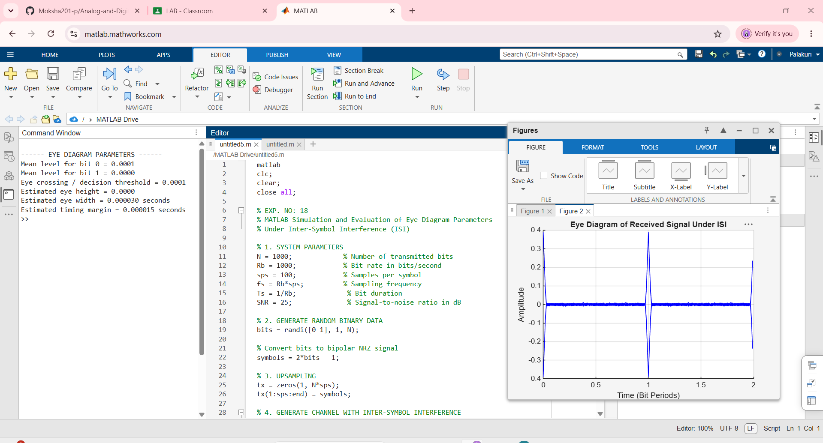
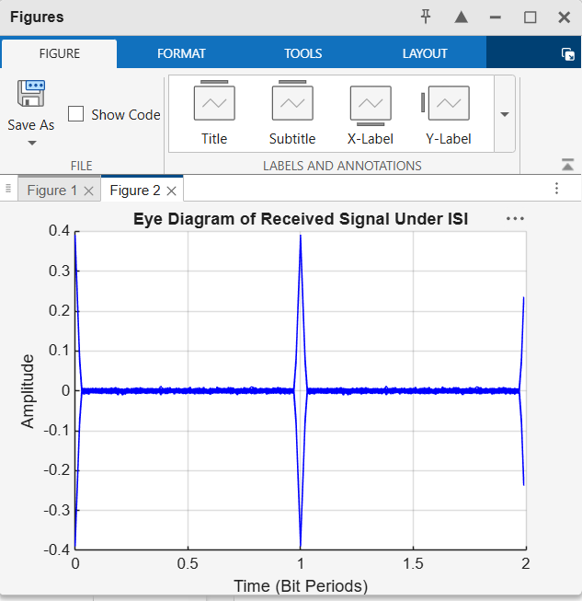
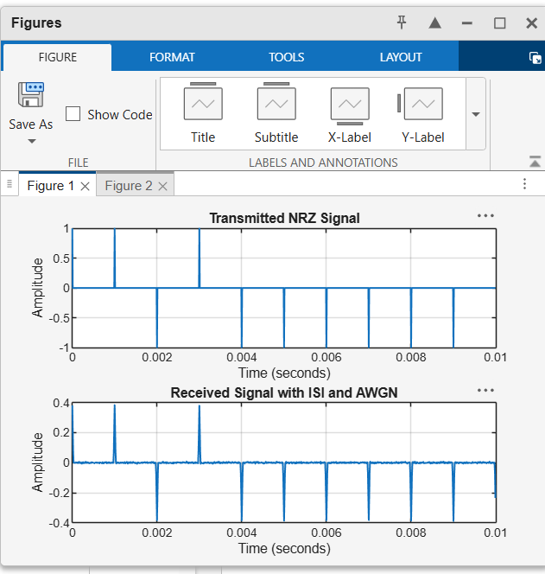
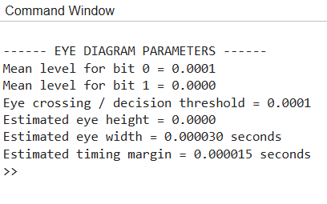

OBJECTIVE:
2. To introduce and study Inter-Symbol Interference (ISI) under different channel
conditions, and evaluate its effect on eye-diagram opening and overall digital signal
quality.
PROGRAMMING CODE:
clc;
clear;
close all;

% EXP. NO: 18
% Study of ISI Under Different Channel Conditions

% 1. SYSTEM PARAMETERS
N = 1000; % Number of bits
Rb = 1000; % Bit rate
sps = 100; % Samples per bit
fs = Rb*sps; % Sampling frequency
SNR = 25; % Signal-to-noise ratio in dB

% 2. GENERATE RANDOM BINARY DATA
bits = randi([0 1],1,N);

% Convert binary data into bipolar NRZ levels
symbols = 2*bits-1;

% Upsample the transmitted symbols
tx = zeros(1,N*sps);
tx(1:sps:end) = symbols;

% 3. DEFINE DIFFERENT CHANNEL CONDITIONS

% Ideal channel
h1 = 1;

% Channel with moderate ISI
h2 = [0.2 0.6 1 0.6 0.2];

% Channel with severe ISI
h3 = [0.4 0.8 1 0.8 0.4];

% Normalize channel responses
h2 = h2/sum(h2);
h3 = h3/sum(h3);

% 4. PASS SIGNAL THROUGH DIFFERENT CHANNELS

rx1 = conv(tx,h1,'same');
rx2 = conv(tx,h2,'same');
rx3 = conv(tx,h3,'same');

% 5. ADD AWGN NOISE TO EACH RECEIVED SIGNAL

rx1 = addNoise(rx1,SNR);
rx2 = addNoise(rx2,SNR);
rx3 = addNoise(rx3,SNR);

% 6. PLOT RECEIVED SIGNALS

t = (0:length(tx)-1)/fs;
display_samples = min(1000,length(tx));

figure;

subplot(3,1,1);
plot(t(1:display_samples),rx1(1:display_samples));
title('Received Signal - Ideal Channel');
xlabel('Time (seconds)');
ylabel('Amplitude');
grid on;

subplot(3,1,2);
plot(t(1:display_samples),rx2(1:display_samples));
title('Received Signal - Moderate ISI');
xlabel('Time (seconds)');
ylabel('Amplitude');
grid on;

subplot(3,1,3);
plot(t(1:display_samples),rx3(1:display_samples));
title('Received Signal - Severe ISI');
xlabel('Time (seconds)');
ylabel('Amplitude');
grid on;

% 7. GENERATE EYE DIAGRAMS

signals = {rx1,rx2,rx3};
titles = {'Ideal Channel','Moderate ISI','Severe ISI'};

figure;

for c = 1:3
subplot(3,1,c);
hold on;

rx = signals{c};
eye_length = 2*sps;
num_traces = min(100,floor((length(rx)-eye_length)/sps));

for k = 1:num_traces
start_index = (k-1)*sps+1;
end_index = start_index+eye_length-1;

if end_index <= length(rx)
segment = rx(start_index:end_index);
time_eye = (0:eye_length-1)/sps;
plot(time_eye,segment);
end
end

title(['Eye Diagram - ',titles{c}]);
xlabel('Time (Bit Periods)');
ylabel('Amplitude');
xlim([0 2]);
grid on;
hold off;
end

% 8. CALCULATE BIT ERROR RATE

BER = zeros(1,3);
signals = {rx1,rx2,rx3};

for c = 1:3
rx = signals{c};

% Sample near the center of each bit
sample_indices = round(sps/2):sps:length(rx);
sample_indices = sample_indices(sample_indices <= length(rx));

% Align sample positions with transmitted bits
received_samples = rx(sample_indices);
detected_bits = received_samples > 0;

valid_bits = min(length(bits),length(detected_bits));

BER(c) = sum(bits(1:valid_bits) ~= ...
detected_bits(1:valid_bits))/valid_bits;
end

% 9. DISPLAY RESULTS

fprintf('\n----- ISI PERFORMANCE COMPARISON -----\n');
fprintf('Ideal Channel BER = %.4f\n',BER(1));
fprintf('Moderate ISI BER = %.4f\n',BER(2));
fprintf('Severe ISI BER = %.4f\n',BER(3));

figure;
bar(BER);
set(gca,'XTickLabel',{'Ideal Channel','Moderate ISI','Severe ISI'});
ylabel('Bit Error Rate (BER)');
title('Effect of Channel ISI on Bit Error Rate');
grid on;

% 10. LOCAL FUNCTION TO ADD AWGN
function y = addNoise(x,SNR)
signal_power = mean(x.^2);
noise_power = signal_power/10^(SNR/10);
noise = sqrt(noise_power)*randn(size(x));
y = x+noise;
end
OUTPUT:
